Lecture No.34 PARASITOLOGY DR. Raad H.H.

Order Siphonaptera (fleas)
- about 2,500 described species
- most on mammals; some on birds
- laterally compressed
- compound eyes absent; some with ocelli
- hind legs longer than others, used for jumping. Resilin is a protein found associated with the legs and is capable of releasing 97% of its potential energy. The flea compresses the pad when it prepares to jump.
- posterior air-current sensory structure termed pygidium
- some species with ctenidia (series of thick, sharp spines arranged as a comb)
  - genal ctenidium (ctenidium on head)
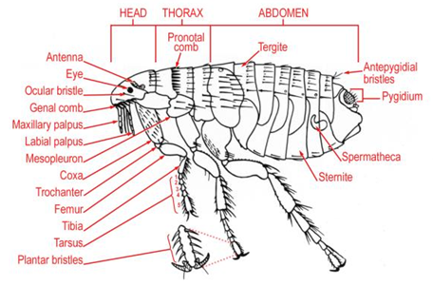
  - pronotal ctenidium (ctenidium on posterior portion of first thoracic tergite)

- body setae generally arranged in dorso-ventro rows and directed posteriorly. Used to keep flea from being easily dislodged by host grooming. The spacing between rows tends to correlate with (slightly wider than) average diameter of hair shafts of preferred host (at least, with a few species)
- during feeding, maxillary laciniae cut back and forth to pierce the skin. The epipharynx is elongate and enters a blood vessel. Saliva enters the wound created by the laciniae, but does not enter the blood vessel.
- life-cycle of typical flea:
  - most (but not all) females lay eggs on host. Generally a few to up to 20 eggs layed at a time, and over a course of a couple months to 6 months, depending upon species, perhaps several hundred eggs may be layed. In some species, egg laying strongly tied to humidity. Eggs usually fall to ground within a few hours of drying
  - eggs hatch within a few days, but sometimes take 3 weeks or longer to hatch depending upon temperature
  - maggot-like larvae hatches and ingests detritis (i.e. decaying vegetation, epithelial cells), usually within a nest; highly sensitive to humidity.
  - most species have 3 larval instars, and each instar lasts about 1.5-2 weeks. However, low temperatures can prolong a stage for up to 200 days in some species.
  - larvae will seek out areas with appropriate humidity, within less than 1 meter from hatching source
  - pupa forms; much of pupal case formed from silk-like material derived from salivary secretions, and detritis picked up from environment. Development in the pupa generally lasts about 1 week. However, low temperatures can retard pupal development for up to a year.

- Xenopsylla cheopis life cycle:

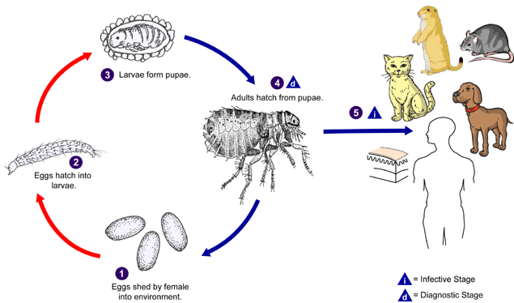

- adult fleas can live for long periods of time without feeding; each species is different but some may go over a year. A few species can even withstand freezing for months at a time.
- fleas apparently sensitive to odors and particular species home in to specific hosts based on these odors
- fleas typically cue in on light, and especially light/shadow/light scenarios. Also temperature.
- some species capable of hosting tapeworm cysticercoids. Some species may transmit diseases such as bubonic plague
- representative species (Pulicidae)
  - Ctenocephalides felis (cat flea; found in large numbers of hosts; has replaced most other species of fleas on medium-sized mammals in Kansas; worldwide; genal and pronotal combs present; meral rod present)
  - Hoplopsyllus anomalus (infects California ground squirrels and rats; can transmit plague relatively easily; pronotal comb only)
  - Pulex simulans (canid/coyote flea; found on many mammals in North America; genal and pronotal combs absent; meral rod absent)
  - Xenopsylla cheopis (oriental rat flea; prefers rats but will bite other hosts; found worldwide; efficient vector of bubonic plague; genal and pronotal combs absent; meral rod present)
- representative species (Ceratophyllidae)
  - Ceratophyllus niger (Western chicken flea; worldwide)
  - Diamanus montanus (on squirrels in the Western and Central US; pronotal comb only)
  - Nosopsyllus fasciatus (European rat flea; in Europe and North America; pronotal comb only)
- invasive species
  - Echidnophaga gallinacea (some texts place this in the Pulicidae; others in the Tungidae)
    - infests birds and mammals; termed the stick tight flea, often found on the head of birds such as chickens, and occasionally on companion animals (i.e. dogs and cats) that have had with contact with barnyard birds. Fleas may be on ears or between toes. Occasionally reported from other mammals, including humans
    - buries mouthparts in host dermis and remains in place. Tends to prefer soft tissues devoid of hair or feathers. In birds, around eyes, on comb, around anus; often congregate in masses. Heavy infections can cause enough inflammation for eyes of chickens to swell shut
    - may cause dermal ulcers; eggs layed into ulcers and larvae hatch and drop to ground where they feed on organic waste materials
    - after emerging from pupa, adults mate and females only attach to new host
    - tropical and subtropical areas; southern portion of US. May be found further north on migrating birds, but is apparently unable to sustain a reproducing population in north temperate latitudes
  - Tunga penetrans (Tungidae)
    - female penetrates skin, normally between toes or fingers
    - male copulates through aperature in skin
    - female expands to size of pea
    - lays eggs in sinus between herself and host
    - eggs hatch; larvae exit through aperature
    - larvae and pupae in soil
    - complications include pain, inflammation, secondary bacterial infections, tetanus, and gangrene
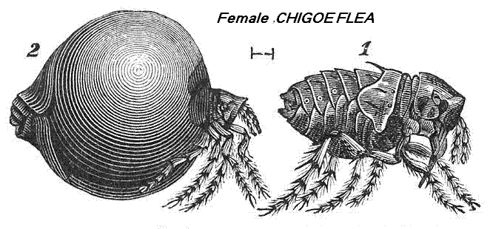
    - infects wide range of mammals in Central and South America; introduced into Africa

- Tunga penetrans (sand flea) which also "CHIGOE FLEA" parasitizing human & cause irritation & inflammation & ulceration especially the toes & toe's nail.

- fleas often vectors of some diseases :
  - murine typhus (Rickettsia mooseri) transmitted by numerous species of fleas, and rats tend to be the preferred host. In humans, the disease results in about 2 weeks of fever, chills, and pain
  - bubonic plague (Yersinia pestis) transmitted by various fleas but most commonly Xenopsylla cheopis. Rodents the primary hosts.
  - myxomatosis (a virus that can kill old world rabbits) and is transmitted by various arthropods, including ticks
  - Dipylidium caninum (dog tapeworm) cysticerci can develop in some species of flea
- Treatment:
The goal of treatment is to get rid of the fleas by treating the home, pets, and outside areas with insecticide. Small children should not be in the home when insecticides are being used. Birds and fish must be protected during spraying. Home foggers and flea collars do not always work.
If flea bites occur, an over-the-counter 1% hydrocortisone cream can help relieve itching.

